

Automation Requirements

Projects | USME – Ascent Rental Salesforce CRM Implementation
Prepared For | USME
Document Status

Document Control and Purpose
This document specifies what the new order automations must do when Workato is the middleware between customer channels (email, SFTP, EDI and others) and the Salesforce Order Intake that creates orders in Ascent Rental. USME Workato Middleware for Order Automation: Functional Design Specification.

1. Summary
- Workato is the middleware It handles orchestration, data mapping and error logging, and delivers orders into the Salesforce Order Intake, which creates the Ascent sales order.
- Three channels go into Workato directly, in this order of preference: the DaVita purchase order email with PDF attachment, then SFTP files, then EDI. Eric's reason for the order: DaVita is sales-only (no pickups) and the cleanest to start; SFTP carries PHI; EDI is being moved to a JSON output.
- Four channels stay in Power Automate for now: email body orders, fax (OCR/AI model already trained), RPA flows and secure email. They post to one standard Workato endpoint so everything lands on the same Intake. Replacing them is a later option that depends on time.
- Every automation must cover rental delivery, sale delivery and pickup orders; convert legacy partner identifiers until after go-live; and, on failure, email the order details to the customer service team to enter manually.
- Open risks: PHI encryption inside Workato is unresolved; Workato's transaction licence (100K to 300K range, to be confirmed) and Salesforce API use (about 200K) need a cost check; and the call and the playbook differ on EDI transport and on how orders reach Ascent (section 4).

2. Scope

2.1 Channels and decisions from the call
Channel | Today | Decision (Oct 23)
Email, PDF attachment (DaVita PO) | Email, ServiceNow document intelligence (OCR), ServiceNow flow, GoUSME API | Into Workato directly.
SFTP | Power Automate, SFTP, blob storage, email | Evaluate pulling files straight into Workato. Files hold PHI. Files must be broken into data elements.
EDI (850, 180 in; 810 out) | Azure Functions, CLEO VAN, AS2, blob, email | Target for Workato. EDI team is working toward JSON output and will share samples.
Email, body | Power Automate front-end handler | Stays in Power Automate. Open an endpoint so it can call Workato. May move later.
Fax | Power Automate, eFax, OCR/AI model | Stays in Power Automate. The model is hard to rebuild and retrain.
RPA (Sentinel) | Power Automate, RPA VM, site login | Stays. Workato RPA is limited and some flows must log in to websites.
Secure email | Power Automate, ServiceNow RPA, secure site | Stays in Power Automate (RPA).

2.2 Order types and message types
Item | Requirement
Order types | Rental delivery, sale delivery and pickup, across all automations .
EDI inbound | 850 purchase order and 180. The 180 is read here as the X12 return merchandise authorization transaction [Validate]. The 850 "no-fill" is a special 850 that updates an existing order or rental and does not create a new intake or order.
EDI outbound | 810 invoice. 855 acknowledgment possibly to be added, to be confirmed (USME learned of it the day before the call).

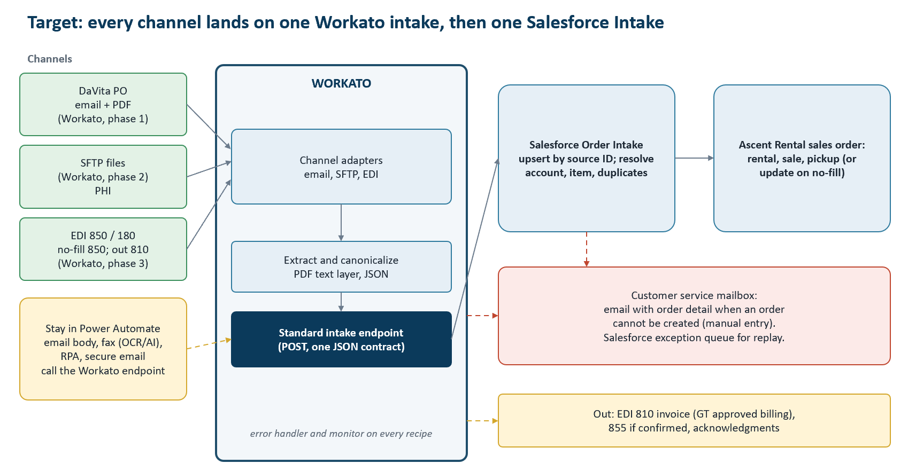
Figure 1. Target channel flow. Green: ingested directly by Workato. Amber: stays in Power Automate and calls the Workato endpoint.

3. Roles and Responsibilities
Party | Responsibility
USME IT Team | Samples and edge cases for DaVita, SFTP and EDI; the customer service mailbox; existing Power Automate flows; EDI JSON; confirming business rules; sample PHI redaction.
Durvah Team | Workato design and build: adapters, extraction, canonical transformation, error handling, monitoring; Salesforce Intake load; Workato RPA and PHI checks.

4. Agreed Position and Source Differences
Topic | Call (Oct 23) | Playbook v1.1
Middleware | Workato is the middleware: orchestration, mapping, error logging. | Same; Workato owns transport, Salesforce owns business decisions.
Fax, email body, RPA | Stay in Power Automate for now; call a Workato endpoint. | Target is eFax API and Workato adapters, with RPA only as an edge adapter.
PDF extraction | Digital text layer, not OCR; PDF format varies. | Document intelligence (IDP) with confidence scores and a review path.
Order creation in Ascent | Workato to Ascent is manageable; using Ascent APIs. | Same-org Salesforce Flow or Apex creates the Ascent order; Workato not needed for that hop.
EDI transport | EDI team moving to JSON output; Workato to ingest. | Workato EDI with Orderful replaces CLEO/VAN (about $90K a year); two IDNs: Encompass Health 1,695 and Ballad Health 2.
Failure | Email order details to customer service for manual entry. | Exception console in Salesforce, replay from the persisted Intake.

5. Functional Requirements

A. Platform and general
ID | Requirement | Pri | Acceptance criteria
AUT-A01 | Workato shall receive, extract, map and deliver each order from the channels in scope to the Salesforce Order Intake, which creates the Ascent order. | M | End-to-end order per channel
AUT-A02 | Workato shall expose one standard external endpoint with a single order JSON contract that Power Automate flows (email body, fax, RPA, secure email) and the Workato adapters call. | M | All channels post the same contract
AUT-A03 | Every automation shall support rental delivery, sale delivery and pickup orders, carried as an order type on the intake. | M | Test case per order type per channel
AUT-A04 | Workato shall create the Intake only after durable acceptance; a repeated delivery of the same source shall not create a second order (idempotency by source ID). | M | Replay test
AUT-A05 | Customer-specific rules (sender, subject, mailbox, partner IDs, file layouts) shall be configuration, not recipe code. | S | Change without redeploy
AUT-A06 | Dev, test and production connections for Workato, Salesforce, email, SFTP and EDI shall be separate; credentials are not held in recipes. | M | Environment matrix
AUT-A07 | The existing mailbox feeding the DaVita automation shall be redirectable to a specific address as development proceeds; today the email goes to three environments. | M | Address changed without code

B. DaVita email with PDF purchase order

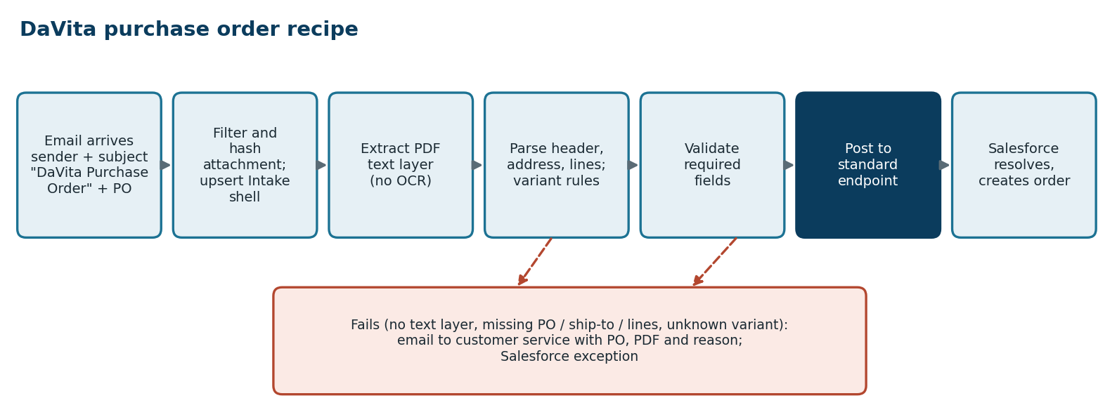

Step | Design
Trigger | Email connector on a controlled mailbox; the mail is redirected there from the current three environments. Filter on the single sender and a subject beginning "DaVita Purchase Order" with the PO value.
Attachment | Take the PDF; compute the hash; archive; Source ID EMAIL:message-id (plus hash).
Extract | Read the digital text layer, thru IDP Connector. If the layer is empty, go to failure, or to a fallback extractor
Parse | Locate fields by labels and structure, not by fixed positions, because the layout is not fixed: header (PO, ship-to, contact), address (second line optional), variable line count, long emails that wrap. Detect the PO version and apply that version's rule set; unknown version fails to review.
Validate | PO number, ship-to, one or more lines each with quantity and item. Sales only; no pickup.
Post | Map to the order intaket (intake_type SALE_DELIVERY). DaVita internal codes go in customer_item_code for the Salesforce crosswalk.
Test base | Samples from USME

Requirements
ID | Requirement | Pri | Acceptance criteria
AUT-B01 | Workato shall monitor the mailbox and select only mail from the single DaVita sender address with a subject of "DaVita Purchase Order" followed by the PO value. Other characteristics may be added. | M | Other mail ignored
AUT-B02 | Workato shall take the PDF attachment and read its digital text layer. OCR shall not be the primary method. | M | Text extracted from sample PDFs
AUT-B03 | If a PDF has no usable text layer, the order shall go to the failure path (B07) or an approved OCR/IDP fallback [Validate]. | S | Scanned PDF test
AUT-B04 | The parser shall handle: one or many line items; an optional second address line (the line is absent when empty); long email addresses that wrap to a second line; and the several PO versions already in use. | M | Test set from Eric's samples and Avery's cases
AUT-B05 | The order shall be a sales order only, with no pickup. A DaVita PO that implies a pickup shall be rejected to the failure path [Validate]. | M | Pickup test
AUT-B06 | Required elements (PO number, ship-to, at least one line with quantity and item) shall be validated before posting. | M | Missing-field tests
AUT-B07 | If the order cannot be created, Workato shall email the customer service team the order information and the source PDF so they can enter it manually (see G). | M | Failure test
AUT-B08 | DaVita product values are internal procurement-system codes; Workato shall pass them as received, for the Salesforce crosswalk to resolve. | M | Raw code kept on the line
AUT-B09 | The original email and PDF shall be archived and referenced from the Intake. | M | Link on the record

C. SFTP files
ID | Requirement | Pri | Acceptance criteria
AUT-C01 | Workato shall connect to the existing SFTP folders as a client, keeping current host names and paths, and pick up new files. | M | New file processed
AUT-C02 | Files hold limited, structured data that must be broken out into specific data elements per customer layout. | M | Layout spec per customer from samples
AUT-C03 | Source key shall be partner, path, file name and file hash, so a file is never processed twice. | M | Re-drop test
AUT-C04 | Files contain PHI. PHI shall be handled under section H before any other step. | M | H requirements met
AUT-C05 | After success, the file shall be archived or moved where the endpoint allows; if not, the source key prevents reprocessing. | S | Archive check
AUT-C06 | Schema or layout violations shall go to the failure path with the file name and reason. | M | Bad-file test

D. EDI

Message | Design
850 new order | Normalizes the JSON from the EDI path (or Orderful) into the Intake; keeps interchange, group and transaction numbers; barcode and product ID
850 no-fill | Finds the existing order or rental by partner order ID and PO and updates it. No new Intake is made for a new order. Recommended: a small audit record linked to the updated order (email to customer service and exception).
180 | Mapped by its meaning (return or RMA) to a transaction intent [Validate].
810 out | Builds the 810 from GT approved billing data, sends it by the agreed transport, and checks control totals against GT. It does not read from Ascent.
855 out | Is built only if the 855 is confirmed
Transport | Stage A: Workato takes the JSON the EDI team produces from the current path. Stage B: Workato EDI with Orderful replaces CLEO/VAN; each partner certified and run in shadow before cutover (playbook).

ID | Requirement | Pri | Acceptance criteria
AUT-D01 | Workato shall receive inbound 850 purchase orders and 180 transactions as delivered by the EDI team in JSON, and create the intake for each new order. | M | Sample 850 creates an order
AUT-D02 | A "no-fill" 850 shall update the existing order or rental and shall not create a new intake or order. If no matching order is found, it goes to the failure path. | M | No-fill test; unmatched test
AUT-D03 | A 180 shall be handled per its meaning (return or RMA) and mapped to an order type | M | 180 sample
AUT-D04 | Workato shall send an outbound 810 invoice for partners that require it, sourced from approved billing data in GT, not rebuilt in Ascent. | M | 810 totals match GT
AUT-D05 | An outbound 855 acknowledgment shall be supported if USME confirms it is required. | C | Decision first
AUT-D06 | Interchange, group and transaction control numbers and trading-partner order IDs shall be kept on the intake. | M | Trace from X12 to order
AUT-D07 | The barcode and product ID that EDI may carry shall be passed for matching (serialized asset and item). | M | Barcode resolved
AUT-D08 | EDI transport (current CLEO/VAN path or Workato EDI with Orderful) is decided in D4; the requirements above apply to either. | M | Decision recorded

E. Standard endpoint for Power Automate channels
ID | Requirement | Pri | Acceptance criteria
AUT-E01 | The endpoint shall accept the order JSON from Power Automate for email body, fax, RPA and secure-email orders, and return a receipt with the Intake number once the intake is stored. | M | Call from each flow
AUT-E02 | Callers shall authenticate; unauthenticated or malformed calls are rejected. | M | Auth tests
AUT-E03 | Power Automate shall keep the receive and extract steps unchanged; only the final "create order" step is repointed to the endpoint. | M | No change to extraction
AUT-E04 | The logic that picks which identifier to use ("logic hierarchy") stays in the fax and Power Automate flows unless found elsewhere to be needed [Validate]. | S | Confirmed in review

F. Legacy identifiers
ID | Requirement | Pri | Acceptance criteria
AUT-F01 | Partners send legacy identifiers until after go-live. Partner ID maps to Account; Model ID to Item; EDI barcode to the serialized asset; EDI product ID to Item. | M | Mapping test per identifier
AUT-F02 | Where only a description is sent, a description lookup shall find the unique identifier; ambiguous results go to review and are not guessed. | M | Ambiguity test
AUT-F03 | The raw value received and the resolved value shall both be kept on the line. | M | Both visible
AUT-F04 | The mapping tables shall be maintained in Salesforce by USME and used by Workato and Salesforce; no mapping is hard-coded in recipes (D5). | M | Mapping change without redeploy

G. Errors and notifications
ID | Requirement | Pri | Acceptance criteria
AUT-G01 | If an order cannot be created (missing required elements, no mapping, system fault after retries), Workato shall email the customer service team with the order details and source document. | M | Email received with all fields
AUT-G02 | The same failure shall create a visible exception in Salesforce with owner, reason and the job reference, and shall be replayable without the customer re-sending. | M | Replay test
AUT-G03 | Retries shall apply only to temporary faults (network, API); bad business data shall not be retried. | M | Fault classification test
AUT-G04 | The customer service mailbox address shall be configurable per environment (USME to provide it). | M | Address set
AUT-G05 | Failures shall not carry PHI in plain text in the notification subject or in logs beyond what customer service needs; see H. | M | Review of sample email

H. PHI and security
ID | Requirement | Pri | Acceptance criteria
AUT-H01 | SFTP and EDI files, and DaVita PDFs where they carry patient data, shall be treated as PHI end to end, including inside Workato (open item Q1). | M | Approach agreed before SFTP and EDI build
AUT-H02 | Salesforce tokenizes and encrypts PHI at order creation. Workato shall either tokenize PHI fields on entry, or hold them only in memory, with job history that does not retain PHI [options in the design document; Validate]. | M | Test run shows no PHI in job history
AUT-H03 | Sample files given to Durvah shall have PHI replaced by a representation; production samples are not used in development. | M | Redaction confirmed
AUT-H04 | Access to Workato jobs, connections and archives shall be limited by role; integration identities are non-human and least-privilege. | M | Access review
AUT-H05 | A business associate agreement and Workato's data-handling settings shall be confirmed for PHI [Validate]. | M | Documented

I. Monitoring and licensing
ID | Requirement | Pri | Acceptance criteria
AUT-I01 | Failed jobs, stopped recipes and aged exceptions shall alert the integration owner daily. | M | Alert test
AUT-I02 | Order counts per channel shall be reconcilable between source, Workato and Salesforce. | S | Daily count agrees
AUT-I03 | Expected Workato transaction volume shall be estimated per channel and checked against the licence limit, and Salesforce API calls against the current use of about 200K, before build (Q2). | M | Sizing agreed

6. Test Scenarios
# | Scenario | Expected
T1 | DaVita PO, one line, no second address line | One sales intake; order created
T2 | DaVita PO, many lines, wrapped email address, second address line | All lines and fields read correctly
T3 | Each known DaVita PO version (samples and cases from Avery) | All versions parse
T4 | DaVita email from another sender, or another subject | Ignored
T5 | PDF with no text layer | Failure path; email to customer service
T6 | Same email delivered twice | One order
T7 | SFTP file with each customer layout; PHI present | Parsed; no PHI in logs
T8 | Same SFTP file dropped again | Not reprocessed
T9 | EDI 850 new order; EDI 180 | Order created; 180 handled
T10 | EDI 850 no-fill with matching order; with no match | Existing order updated; unmatched goes to failure
T11 | Outbound 810 for an invoiced order | Totals agree to GT
T12 | Power Automate fax and email-body flow posts to endpoint | Intake receipt; same result as before
T13 | Legacy partner ID, model ID, barcode; description-only line | Resolved or sent to review
T14 | Salesforce unavailable during processing | Retries; then exception; replay works
T15 | Each order type: rental delivery, sale delivery, pickup | Correct type reaches Ascent

7. Decisions and Open Questions
ID | Topic | Question or recommendation | Owner
D1 | Power Automate channels | Keep fax, email body, RPA and secure email in Power Automate through go-live, calling the standard endpoint (call). Plan the playbook's eFax and Workato adapters afterwards. | Eric / Sourabh
D2 | PDF extraction | Use the text layer as primary (Eric). Add IDP only as fallback for scanned or damaged PDFs. | Eric
D4 | EDI transport | Stage A: Workato consumes the JSON that the EDI team is producing from the current path (call). Stage B: Workato EDI with Orderful replacing CLEO/VAN (playbook, about $90K a year). Confirm sequence and whether Phase 3 includes Orderful onboarding and partner certification. | Sourabh / Eric
D6 | No-fill 850 | Eric: no intake or order created. Recommend a lightweight audit record linked to the updated order, not a new Intake. | Eric
Q1 | PHI in Workato | Can Workato encrypt or tokenize PHI, and what does job history retain? Who signs the BAA? | Durvah / USME
Q3 | 855 and 180 | Confirm the 855 is required and what the 180 is used for. | Eric
Q4 | Notification | Who receives failure emails, and what detail is allowed in them (PHI)? | Eric

